Eggs: $4.00 / Dozen
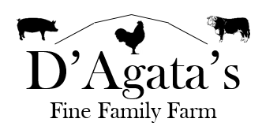
Chicken:
Whole Roasting Chicken: $4.00/lb
Pork:
Loin Roast: $4.10/lb
Bone-in Pork Chops: $5.00/lb
Pork Tenderloin: $9.50/lb
Pork Butt Roast: $4.10/lb
Country Style Ribs: $4.50/lb
Baby Back Ribs: $7.50/lb
Bacon: $10.00/lb
Sausage (loose): $5.00/lb
Hot Italian

